**Native app design for the Restaulogy client side:**

**@ Way to communicate from the QRCOde to our native app:**

Our current functionality for the Restaulogy client app starts with the QRcode link which opens particular table session and the options associated with that.

So in this case we need to first check whether we can able to open the app and able to pass the QRcode link parameters to it.

**A] User Dashboard:**

We need to provide the options available on dashboard/landing page,

1. Menu
2. Promotions
3. Loyalty reward
4. Reviews
5. Request service
6. Connect

The screen will be similar to our current web app. Also we need same menu options as common header so we can able to access from anywhere.

- We need to store the table and the restaurant to the session by getting the data from the QRCode link

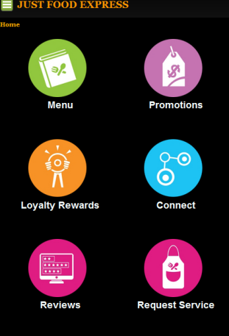 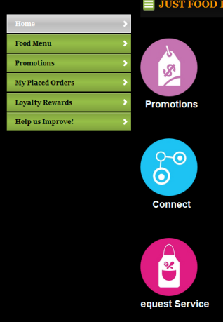

**B] Menu:**

The menu page involves following sections,

1. Menu Listing
2. Sub Menu item listing of specific menu
3. Menu search/filter
4. **Menu Listing :**

* Here we need to show the dropdown list of the all menu s.
* On load we need to connect to web service get the list of all the menus fill into the dropdown.
* Select the first menu by default and save it to the session

1. **Sub Menu item listing:**

* Fetch the list of the submenu items for the saved session menu item from the web service.
* Display the sub menus and items tied to that particular sub menu
* Way to expand/collapse sub menu or show dishes on the separate page
* The layout and design of the dishes listing
* Dish name/picture should be a link which will open the separate dish detail screen.

1. **Menu search/filter:**

* The menu filter/search options,

1. Keyword
2. Items that are
3. Allergy

* Pass the user filter criteria to the web service and return the menus satisfying the criteria.
* Save the user filter in session and on top provide option button/link to clear the filter.
* Display the filtered menus only and rest navigation will be same as step 2.

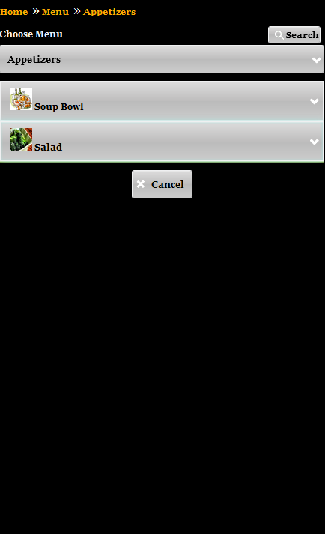 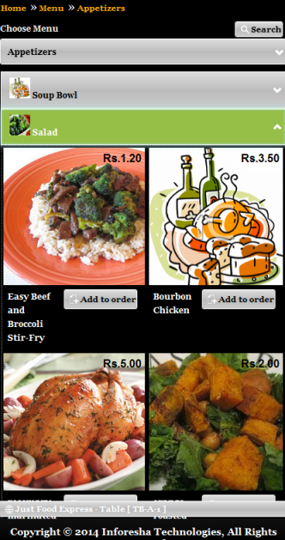 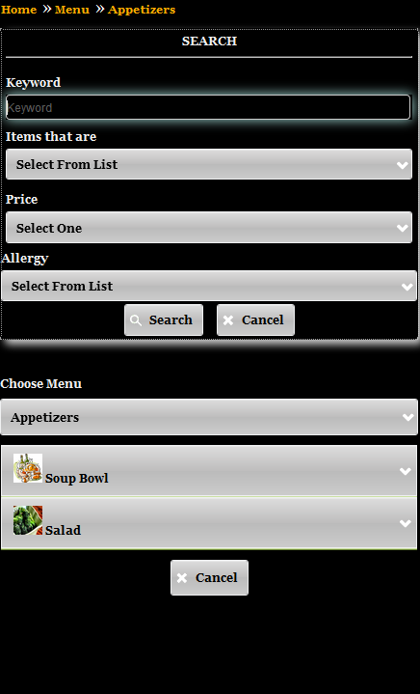

**@ Dish detail screen:**

* Fetch the particular dish details based on the sub menu dish selected.
* Display the dish detail with layout and proper formatting.
* Option to navigate between other dishes of the sub menu. We need to store the next and previous dish link and display to the user.

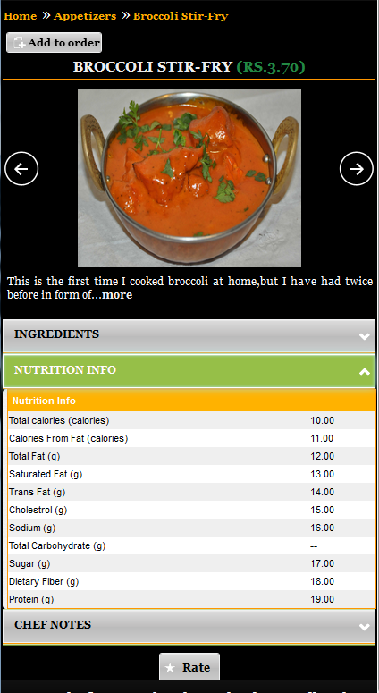

**@ Dish Vote:**

* Dish detail one option for customer to vote the dish
* The fields involved,

1. Rating (dropdown)
2. Email
3. Phone

* Pass the user rating details to web service to save it and on success refresh the dish page to show updated rating.
* Vote option will be enabled only one time for the particular dish and user combination.

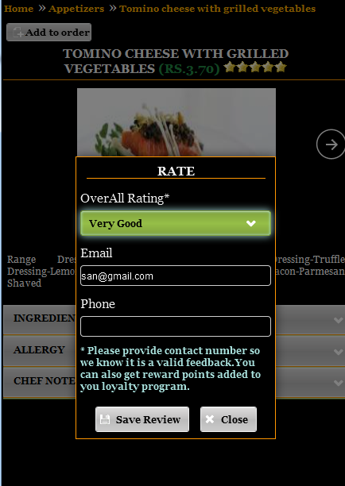

**C] Promotions**

**1) Promotion listing:**

* Fetch active promotion list from the web service.
* Display the promotion in proper layout and formatting.
* Promotions categorized in following ways,

1. Now available
2. Forth coming
3. Events

* For each of the category tab selection fetch the promotions and display inside that tab.
* Each promotion in the listing have following options,

1. Email a Friend
2. Share
3. Remind Me
4. Refer a friend

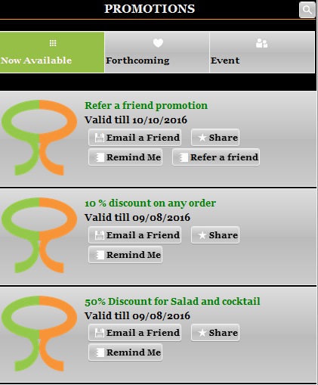

**a) Email a Friend:**

* The screen involves following fields,

1. Friends Email
2. Your Email

* Send the captured emails to the web service and show success/failure message.

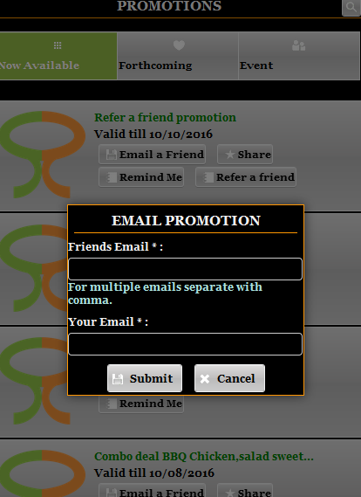

**@ Share:**

* Share with Facebook option button
* The button will open the Facebook and post the promotion on their river feed.
* We need to check on this weather Facebook api provides this.

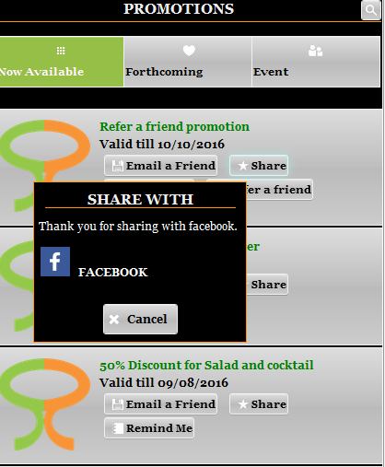

**@ Remind Me:**

* The screen will involve following fields,

1. Email
2. Remind me have following option,
3. X days before the promotion
4. In X days
5. On particular date
6. Pass the fields to the web service and show success and failure message.
7. If same user already set the reminder we need fetch it from the web service and populate the selected values.

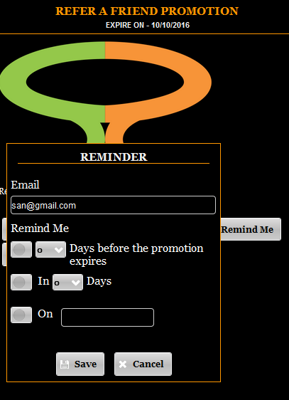

**@ Refer a friend:**

* On refer a friend screen user needs to provide his phone
* We need to pass the captured email to web service which will check if phone s in registered with us else adds and sends sms which he can send to his friends

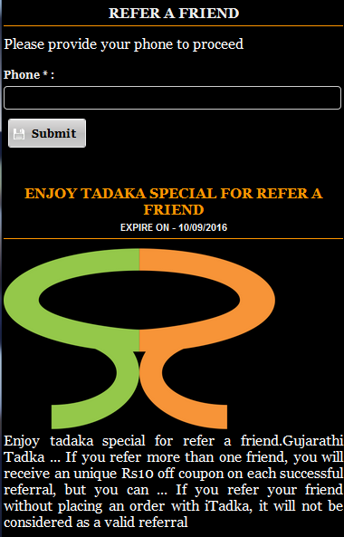

**2) Promotion Detail:**

* On clicking on the promotion name/logo we need to open promotion detail screen which will fetch the promotion details from the server and shows that
* Design of page detail layout with formatting
* The promotion detail have following options,

1. Email a Friend
2. Share
3. Remind Me
4. Add to calendar

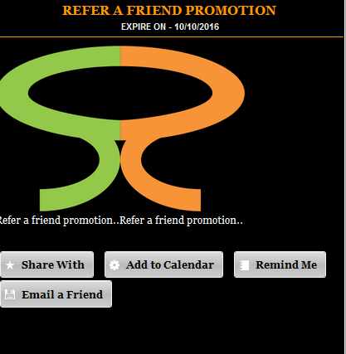

**@ Add to calendar:**

* This involves following options,

1. Google Calendar
2. Yahoo Calendar
3. Windows live Calendar

* We need to check with the android how we can able to add it Google, Yahoo and Windows
* We can fetch the current calendar links from the server and display on the client.

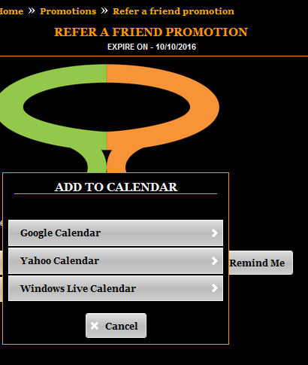

**3] Loyalty reward**

- If user is not already logged in it will ask for the user login. If not already signed up then asks for sign up.

**@ User login:**

* If user is already registered and not logged in it asks user to provide his email/phone and using this user is logged in to the system.

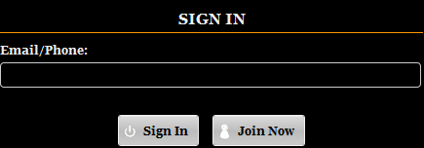

**@ User signup:**

* If user is not already registered with us he needs to sign up, it involves

1. Phone
2. Email
3. Name

* Submit the user entered data to server and show success and failure message
* On success redirect to rewards landing page

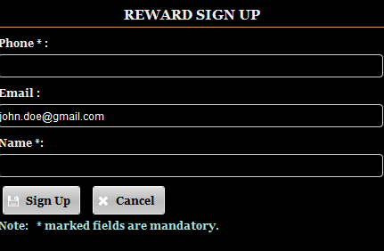

**@ Reward landing page:**

* For the current user fetch following details

1. Points details
2. Loyalty rewards
3. Redeem history
4. Award history
5. Option to ‘Add reward points’

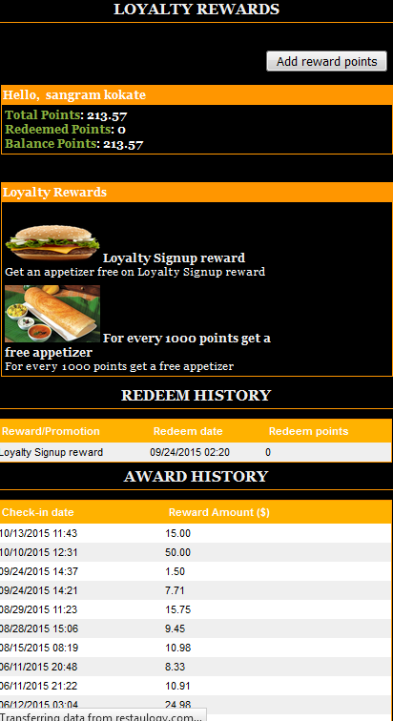

**@ Add reward points:**

* Add reward points involves following fields,

1. Server pin
2. Amount
3. Multiplier

* Validate and submit the input data to server and show the success and failure message
* On success refresh/reload the landing page with updated points and award history

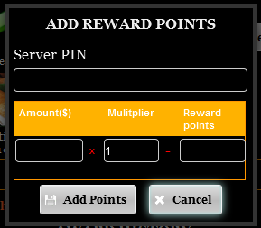

**@ Redeem:**

* We need to show the redeem option for the rewards which he is eligible only
* On clicking redeem submit the reward and user id to server and show success and failure message
* On success refresh/reload the landing page with updated points and award history

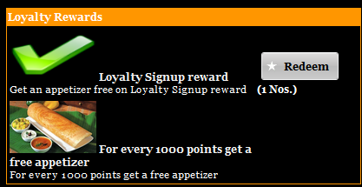

**4] Reviews:**

The reviews bifurcated into two main tabs,

1. Help us improve
2. Write review

**@ Help us improve:**

This screen will have following fields,

a) Description

b) Phone

- On clicking post submit the user inputted data to server and show success and failure message

- User can submit his suggestion only once for restaurant

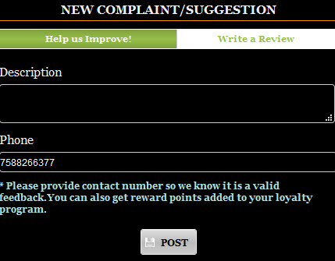

**@ Write review:**

It contains following options,

1. Zomato
2. Tripadvisor
3. Urbanspoon
4. Google

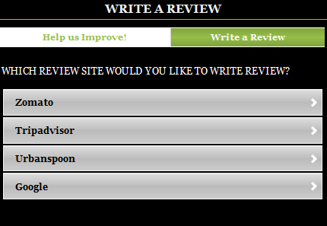

**5] Request service**

It involves two main tabs,

1. Request a table service
2. My requests

**@ Request a table service:**

* In this screen user needs to provide,

1. The service request
2. Name
3. Additional note

* On clicking post submit the user inputted data to server and show success and failure message

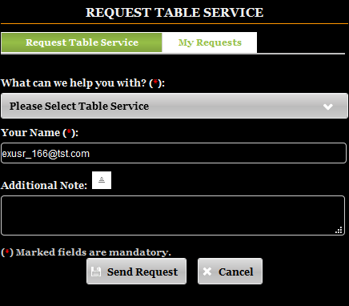

**@ My request:**

* User can see his posted request here.
* We need to fetch the list of his requests for the current table session
* Display the list in proper tabular format.

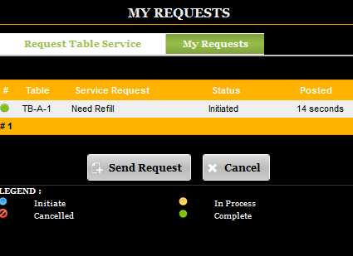

**6] Connect:**

- Fetch the restaurant provided facebook, twitter and instagram links from the server and display it on new page.

